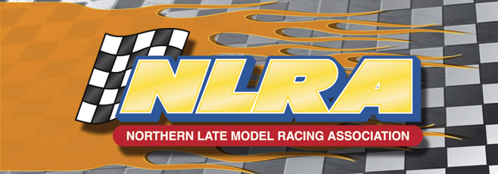

To Whom it May Concer:

Please accept this letter as a request for door prizes for the NLRA 2016 Annual Awards Banquet, which will take place November 2016.
The Winners names of these door prizes will be listed on our Facebook page so you will know who has won your prize.
We will have a thank you letter sent out shortly after our banquet is complete.
We look forward to your support and thank you in advance.

Brad Seng/President
Pat Mooney/Vice President
Robbin Anderson/Secretary-Treasurer
Tom Corcoran/Competition Director

